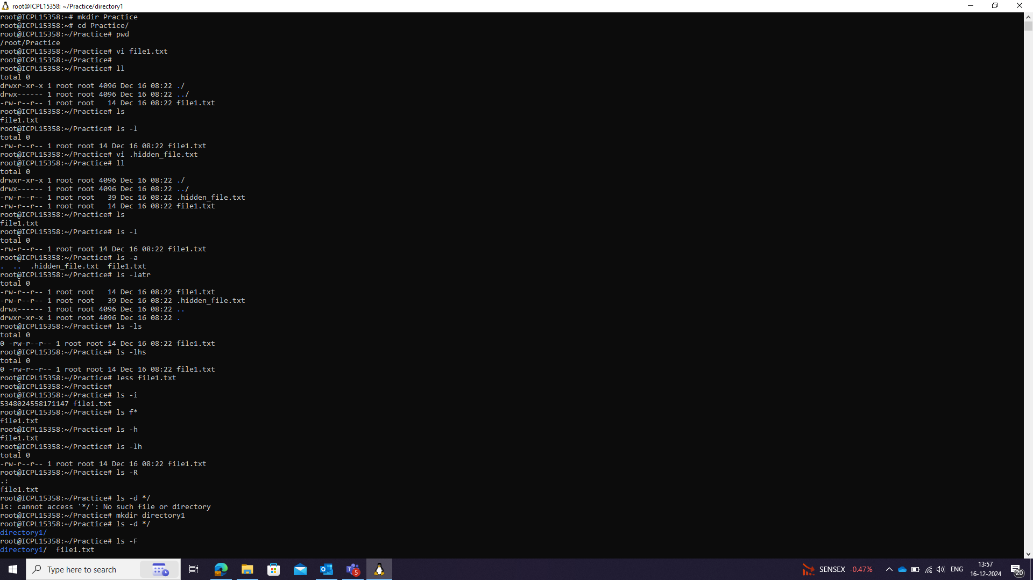

:wq to save the file

